**Chapter I**

**INTRODUCTION**

**Background of the Study**

Artificial Intelligence (AI) has significantly changed various aspects of our lives, including the job market (Makridakis, 2017). An alumni tracker system is a software application that allows educational institutions to monitor the career development of alumni, provide career resources, and gather data to enhance the efficacy of programs and services while maintaining alumni engagement. The integration of AI algorithms in the development of the Alumni Tracker with the Job Matching system has enabled job seekers to find personalized job recommendations based on their skills and qualifications.

The Alumni Tracker with Job Matching using an AI Integration system will collect and analyze data on alumni's education, work experience, skills, and preferences to provide personalized job recommendations. This system offers valuable benefits to alumni by keeping them updated on current job market trends. This system allows alumni to access real-time information about job openings and the specific skills and qualifications needed to excel in those positions. By employing AI algorithms, the system effectively matches alumni with suitable job opportunities, thereby assisting employers in identifying qualified candidates for their vacant positions.

The development of the Alumni Tracker with a Job Matching system using Hybrid filtering, a combination of content-based filtering and collaborative filtering algorithm, highlights the commitment of NONESCOST to support its alumni in achieving success in their chosen careers. This system's innovative approach sets it apart from other alumni tracker systems that may rely on manual processes or limited data analysis. The personalized job recommendations and up-to-date information on job openings provided by the system are crucial features that will help alumni navigate the competitive job market and find opportunities that match their profile.

**Objectives of the Study**

**General Objective**

This study aims to develop an Alumni Tracker with Job Matching using AI Integration.

**Specifically, it aims to**

1. Design a system that will manage the following data of NONESCOST Alumni:
   * 1. education
     2. work experience
     3. skills
     4. job preferences
2. Design a system that will integrate Artificial Intelligence in the following aspects:
   1. Job matching algorithm that can analyze alumni data and provide personalized job recommendations.
   2. The Natural Language Processing (NLP) algorithm analyzes text and offers suggestions for enhancing grammar, punctuation, style, tone, and clarity.
3. Generate the following reports.
   1. Alumni Report
   2. Employer Report
   3. Employment Rate Report
   4. Job Posting Report
4. Determine the quality of the developed system based on **ISO/IEC 25010:2011** Systems and Software Quality Requirements and Evaluation (SQuaRE) Quality Model.

**Scope and Limitation**

The scope of the Alumni Tracker with a Job Matching system is to leverage artificial intelligence (AI) to support the alumni of the NONESCOST in finding job opportunities that align with their unique skills and qualifications. The system will collect data on alumni's education, work experience, skills, and preferences to provide personalized job recommendations. The system will also integrate job postings to match alumni with job openings that are a good fit. The system's primary goal is to help alumni succeed in their chosen careers by connecting them with job opportunities that meet their needs and qualifications.

Taking into account the limitations of the Alumni Tracker with Job Matching system is crucial. Firstly, the system's efficacy heavily depends on the accuracy and timeliness of the information provided by the alumni. Secondly, while the system's matching algorithms strive for optimal job matches, it is important for job seekers to thoroughly evaluate the job opportunities suggested by the system. Additionally, the system's effectiveness may be hindered by the availability of job postings within its database, potentially limiting its ability to capture the entirety of job opportunities in the market.

**Significance of the Study**

The NONESCOST Alumni Tracker with Job Matching using the AI Integration system is designed to benefit several stakeholders, including NONESCOST alumni, employers, and the academic institution itself.

**NONESCOST Alumni**. The primary recipients of the system's benefits are the alumni of the institution.The system will provide personalized job recommendations that match the alumni's education level, work experience, skills, and job preferences. The system will help alumni find job opportunities that align with their career goals, increasing their chances of finding employment that matches their interests and skillset.

**Employers.** The system will benefit employers by providing a pool of qualified job applicants who match their job requirements. A more efficient recruitment process facilitated by the system will benefit employers by reducing the time and resources needed to find suitable candidates. The system will help employers find qualified applicants who match their job requirements, increasing the likelihood of successful job placements.

**Academic Institution.** The system will benefit the educational institution by improving its alumni engagement and support services. By providing a job-matching service for alumni, the institution can enhance its reputation and strengthen its relationships with alumni. The system will also provide valuable data on alumni employment trends, which can be used to improve the institution's academic programs and curriculum.

**Future Researchers.** The project may serve as a reference for future researchers.

**Definition of Terms**

**AI Integration**: Conceptually, AI integration refers to using artificial intelligence algorithms and techniques to enhance the performance and capabilities of a system. Operationally, AI integration in the NONESCOST Alumni Tracker system uses machine learning algorithms to analyze alumni data and provide personalized job recommendations.

**Job Matching**: Conceptually, job matching involves the process of connecting job seekers with appropriate job opportunities by considering factors such as their skills, education, work experience, and personal preferences. Operationally, job matching in the NONESCOST Alumni Tracker system refers to the algorithmic process of analyzing alumni data and employer job requirements to identify suitable job opportunities for alumni.

**Alumni Tracker:** Conceptually, an alumni tracker refers to a system that tracks alumni's academic and employment progress. Operationally, the Alumni Tracker in the NONESCOST system refers to the database and user interface that enables alumni to input and update their personal and career information. The job matching algorithm uses it to provide personalized job recommendations.

**Data Analytics:** Conceptually, data analytics involves analyzing and interpreting data to derive insights and make informed decisions. Operationally, data analytics in the NONESCOST Alumni Tracker system refers to using machine learning algorithms to analyze alumni data and employer job requirements to provide personalized job recommendations.

**Personalized Job Recommendations:** Conceptually, personalized job recommendations refer to job opportunities that match the job seeker's skills, education, work experience, and job preferences. Operationally, personalized job recommendations in the NONESCOST Alumni Tracker system refer to the algorithmic process of analyzing alumni data and employer job requirements to identify suitable job opportunities for alumni.

**Conceptual Framework**

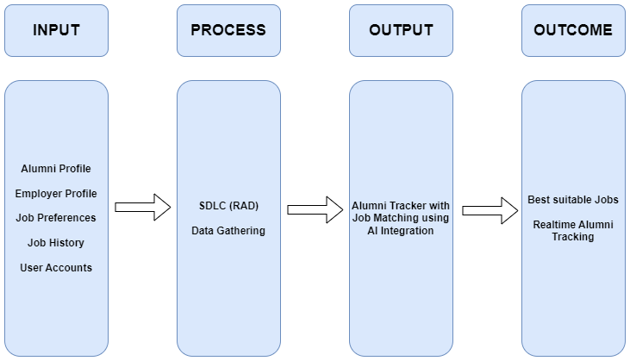

**Figure 1. Conceptual Framework of the Study**

Figure 1 shows the NONESCOST Alumni Tracker with a Job Matching system that uses AI integration to match alumni with job openings. The system is based on the IPOO model and enables employers to find qualified candidates for their job openings while providing real-time tracking of NONESCOST alumni. In summary, it is a tool that simplifies the job-matching process and enhances alumni tracking.

**Chapter II**

**RELATED LITERATURE AND PRIOR ARTS SEARCH**

**Related Literature**

**ALUMNI TRACKING SYSTEM**

Jaiswal et al. (2021) propose an online-based application, the Alumni Tracking System, to enhance the current tracking process of alumni. The system provides a centralized platform for managing alumni data and facilitates communication between alumni and the institution. The proposed method offers significant advantages to the alumni, such as reducing maintenance efforts and providing an all-in-one solution for collecting and managing alumni data.

**An Alumni Portal and Tracking System**

Bista et al. (2021) describe a web-based alumni tracking system that aims to manage alumni data and provide a platform for alumni to update their information and view online yearbooks. The study presents insights from alumni responses, including job positions, employers, current location, and other education preferences. The system has effectively managed alumni data and has been accessed by many alumni, highlighting the importance of an efficient alumni tracking system for institutions.

**Design and Development of Alumni Tracking Information System**

Suryana et al. (2020) developed and evaluated a web-based alumni tracking information system for SMKN 1 Garut using a waterfall model and functional testing. The system was found to be feasible and received a positive response from alumni users. The research highlights the importance of implementing an efficient alumni tracking system and the benefits of a web-based platform for managing alumni data.

**Design and Development of Alumni Tracking System for Public and Private HEIs**

Luciano et al. (2020) developed an alumni tracing system allowing the university to track its graduates using the Internet, providing critical information such as their employment status and essential skills required for their current job. The system can generate comprehensive reports for planning, program implementation, and decision-making purposes. This study emphasizes the importance of an efficient alumni tracking system in providing feedback to HEIs to improve their curriculum and ensure that it meets the needs of the industry.

**Centralized Alumni Management System (CAMS) - A Prototype Proposal**

Mukherjee et al. (2019) proposed a centralized system for alumni management that focuses on alumni networks across institutions and organizations, with a fundamental goal of promoting mentorship processes within and across institutions. The system allows individuals to register as alumni after graduation and while still in school, thereby facilitating networking among professionals and students. The proposed method offers several benefits to alumni and institutions/organizations and exhibits superior features compared to existing proposals.

**Alumni Social Networking Site**

Sivakumari et al. (2021) proposed an innovative solution for keeping alumni engaged by developing a user-friendly alumni website and social networking platform. The platform provides easy access to career guidance, opportunities for students, and networking opportunities with alumnae. The user-friendly interface allows accessible communication and information sharing, which helps maintain a strong relationship between the institution and its alumni. The project aims to create a platform that supports the career development of students while assisting institutions to keep track of their alumni.

**Alumni Database Management System**

The system proposed by Kumar et al. (2019) offers a practical solution for managing alumni data and promoting interaction between alumni, administrators, and students in a college setting. By providing a platform for students to connect with alumni for potential projects or job opportunities, the system can enhance their academic and career development. The automatic transfer of student data to the alumni module upon graduation further streamlines the process and ensures accurate alumni records.

**Alumni Interactive System Using Mining**

The study of Patel et al. (2017) highlights the potential of using data mining algorithms in university alumni systems to strengthen the bond between alumni and their former institutions. By providing a platform for ongoing interaction between graduates and current students, the proposed method could help facilitate career and business opportunities. Additionally, primary data mining algorithms may improve the system's user experience. This study offers valuable insights into the potential benefits of incorporating data mining algorithms into university alumni systems.

**The Alumni Information Management Model Based on "Internet +."**

Dai et al. (2017) introduced a comprehensive framework for an intelligent and integrated alumni information management system. This framework aims to address common issues encountered in alumni management, such as fragmented alumni information, delayed information transmission, and limited functionalities of management systems. The proposed approach combines both online and offline methods to effectively tackle these challenges.The framework consists of three key modules: "Alumni Social Network," "Intelligent Data Acquisition and Storage," and "Data Mining and Decision-Making Support." The primary objective is to establish a social platform for alumni networks, utilizing intelligent technology to gather and store extensive alumni data. Additionally, data mining techniques are employed to enhance decision-making processes regarding talent training schemes.By leveraging the power of the "Internet+," this system endeavors to enhance alumni management practices and promote a more efficient and interconnected alumni community.

**Designing Mobile Alumni Tracer Study System Using Waterfall Method: an Android Based.**

Sadi et al. (2019) aimed to fulfill the requirement for organized compilation and minimal alumni data in the Industrial Engineering Department at UPN Veteran Yogyakarta, Indonesia. They achieved this by creating an Android application designed explicitly for alumni tracking. The researchers adopted a qualitative descriptive methodology and utilized a prototyping system development approach to gather data through interviews and observation. The anticipated outcomes of the study included the development of an Android application for alumni search, analyzing alumni data, and implementation of a survey method to describe graduates' profiles and assess curriculum relevance.

**ATS ANALYSIS, DESIGN, AND DEVELOPMENT OF THE ALUMNI TRACKING SYSTEM OF THE LICERIO ANTIPORDA SR. NATIONAL HIGH SCHOOL-DALAYA EXTENSION**

Umoso (2021) conducted a study to enhance the alumni tracking process at Licerio Antiporda Sr. National High School- Dalaya Extension by designing and developing an online-based alumni tracking system. The research identified the shortcomings and limitations of the existing manual system and introduced a software platform to address these issues. The newly created system provides notable benefits, including convenient access to alumni data and improved communication between alumni and the institution. The study's findings indicate that implementing the online Alumni Tracking System has the potential to serve as a technological tool that enhances the school's management program while providing insights into the alumni's status. Overall, the study's methodology and proposed system make valuable contributions to alumni tracking systems in educational institutions.

**DIGITAL SKILL: OPTIMIZING THE UTILIZATION OF INFORMATION TECHNOLOGY BY PESANTREN UNIVERSITY IN ALUMNI TRACKING ACTIVITIES**

Setyaningsih et al. (2022) conducted a research study that focused on implementing a tracer study at Universitas Darussalam Gontor. The study aimed to optimize the use of information technology by utilizing a website-based alumni tracking system. A qualitative case study approach was employed, and data was collected through interviews and observations. The study's findings indicated that the tracer study successfully optimized the utilization of information technology by implementing a Google form. Additionally, a website-based alumni tracking system was in development. The study also provided recommendations to enhance skills and knowledge for maximizing the effectiveness of the website-based system.

[**A LinkedIn Analysis of Career Paths of Information Systems Alumni**](https://aisel.aisnet.org/cgi/viewcontent.cgi?article=1007&context=jsais)

The study conducted by Case et al. (2013) explored using LinkedIn profiles to obtain a more accurate representation of the entry-level jobs brought by alumni of an Information Systems program and their career advancement over time. The research focused on 175 graduates from the program at a mid-sized comprehensive university in the southeastern United States. The investigation findings suggest that LinkedIn profiles can be utilized to evaluate the long-term outcomes of Information Systems programs, provide insights into career trajectories for IS professionals, and assess the transition from technical roles to managerial positions.

**An Alumni Tracer System for Saint Louis College**

Hufana (2019) proposed a study to create an Alumni Tracer System for Saint Louis College, employing the Software Engineering Process. The developed system underwent usability testing involving IT experts using the WUCET test, the Alumni Affairs and Job Placement Officer, and selected alumni utilizing the WAMMI tool. The testing results indicated that the system exhibited a high level of usability and successfully resolved the limitations of the previous Alumni Tracer System. Based on these findings, the study recommends implementing and adopting the developed Alumni Tracer System by Saint Louis College.

**Tracer Study as an Effort to Improve Alumni Careers in Kadiri University Job Placement Service.**

Safi'I & Priyantoro (2019) conducted a quantitative descriptive study with a cross-sectional approach to investigate graduates' transition from education to the world of work, alumni assessment of higher education's contribution to obtaining competencies, and vertical and horizontal alignment felt by alumni. The target population is 2419, with 955 contactable alumni and 195 alumni responding to the questionnaire. The findings suggest that alumni take an average of six months to secure a job, with most job searches done through personal connections, and private companies are the most common type of workplace. Additionally, most respondents felt that their competencies were vertically and horizontally aligned.

**Web-Based Abulyatama Alumni Information System**

Ardiansyah (2021) developed a web-based E-Tracer study service for STMIK Abulyatama to improve the existing manual system for collecting data on alumni. The research objectives are to analyze the alumni information system, design and develop the alumni management information system and improve the existing system for better performance in alumni data collection. The proposed method is expected to provide more accurate and up-to-date information about alumni, simplify and speed up administrative processes, and benefit curriculum improvements.

**Developing a Tracer Study Information System Based on SMS Gateway to Support Career Development Program in UPI, Cibiru Campus.**

Permana (2019) designed an information system based on SMS Gateway technology to provide job-related information to UPI Kampus Cibiru graduates quickly and sustainably in their scientific fields. The Rapid Application Development method is used in this study to design the system, which is built using HTML Programming Language, PHP, and Bootstrap as a CSS framework. The proposed approach is expected to improve the absorption of UPI Kampus Cibiru graduates in the working environment and indicate the institution's success in organizing the educational process.

**Dashboard-based Alumni Tracer Study Report Using Normalized Data Store Architecture.**

The research by Asroni et al. (2019) aims to develop a data warehouse using the NDS architecture for alumni monitoring at Universitas Muhammadiyah Yogyakarta. The study found some noise in the data, such as invalid data and duplicate data, which were cleaned during the process. The data warehouse met the institution's requirements. It was displayed in a report that was easier to analyze, and the information was made into a dashboard form using the Power BI application.

**E-tracer study implementation of Indonesia Computer University alumni.**

The study of Soegoto et al. (2018) describes the tracer study conducted by Indonesia Computer University in 2016 for its 2014 graduates using an online survey through various communication channels. The research focuses on the response rate and alumni characteristics, such as their transition period, job relevance, and competence. The results show a 28% response rate, a median transition period of four months, and a zero competence gap in research skills, indicating the university's success in achieving its graduates' aim in this area.

**Development of Industry Academe Linkage Alumni and Placement Portal.**

Rosales and Lagman (2017) conducted a study to create an Industry Academe Linkage Alumni and Placement Portal for the FEU Institute of Technology. The purpose of this portal was to automate the workflow and procedures related to internships, industry placements, and alumni tracking. The study adopted the Incremental Model Process as the software process model and utilized ISO 9126 as the framework to assess the acceptability of the developed prototype. Criteria such as functionality, usability, reliability, portability, and supportability were considered during the evaluation. The overall assessment of the system yielded a score of 4.21, indicating that the application was deemed satisfactory and ready for deployment.

**Prior Arts**

**A career counseling system based on intelligent matching algorithms.**

According to Fernandez & Saboia (2021), this paper describes a career counseling system that uses intelligent matching algorithms to help individuals find suitable job opportunities based on their skills and interests.

**A job matching system based on ontology and machine learning.**

Wang & Yao's (2019) article presents a job-matching system that leverages ontology and machine learning to pair individuals seeking employment with relevant job opportunities, taking into account their skills and qualifications.

**A job recommendation system based on multi-criteria decision making**

Zhu et al. (2018) propose a job recommendation system that uses multi-criteria decision-making to recommend job opportunities based on the preferences and qualifications of job seekers.

**A method for using natural language processing to match job seekers with suitable job postings.**

Roush (2017) article describes a method for using natural language processing to match job seekers with suitable job postings based on their skills and qualifications.

**An intelligent job-matching system based on deep learning.**

Zhang et al. (2019), the paper proposes an intelligent job-matching system that uses deep learning algorithms to match job seekers with suitable job opportunities based on their skills and qualifications.

**A hybrid approach for job recommendation using collaborative filtering and content-based filtering.**

This article by Ghorbani et al. (2018) presents a hybrid approach to job recommendation that combines collaborative filtering and content-based filtering to recommend job opportunities based on the preferences and qualifications of job seekers.

**A job-matching model based on an artificial neural network.**

Wang et al. (2018) propose a job-matching model that uses artificial neural networks to match job seekers with suitable job opportunities based on their skills and qualifications.

**Job matching based on ontology and semantic matching.**

Chen et al. (2020) present a job-matching approach that uses ontology and semantic matching to match job seekers with suitable job opportunities based on their skills and qualifications.

**Job matching system based on personality traits and skills.**

Purohit & Kulkarni (2019) propose a job-matching system that uses personality traits and skills to match job seekers with suitable job opportunities.

**Predicting career outcomes using natural language processing and machine learning**

Raza & Murad (2020) study uses natural language processing and machine learning to analyze alumni career data and predict future career outcomes.

**Intelligent career counseling system using data mining techniques**

Tsai (2013) study proposes an intelligent career counseling system that uses data mining techniques to match job seekers with suitable careers.

**A hybrid intelligent system for job matching and career recommendation**

Nandhini & Prakash (2015) study proposes a hybrid intelligent system that combines fuzzy logic, case-based reasoning, and genetic algorithms to match job seekers with suitable careers.

**Development of an intelligent career counseling system using association rule mining**

Kim et al. (2015) study proposes an intelligent career counseling system that uses association rule mining to match job seekers with suitable careers.

**Job recommendation system using machine learning algorithms**

Xia et al. (2021) study proposes a job recommendation system that uses machine learning algorithms to match job seekers with suitable job opportunities.

**A fuzzy logic-based intelligent job-matching system**

Li & Tsai's (2012) study proposes an intelligent job-matching system that uses fuzzy logic to match job seekers with suitable job opportunities.

**Intelligent career path recommendation system using machine learning algorithms**

Lee (2018) study proposes an intelligent career path recommendation system that uses machine learning algorithms to recommend suitable career paths for job seekers.

**A career guidance system based on clustering analysis**

Kwon et al. (2015) study proposes a career guidance system that uses clustering analysis to match job seekers with suitable careers.

**An intelligent job-matching system using rule-based reasoning**

Lee's (2016) study proposes an intelligent job-matching system that uses rule-based reasoning to match job seekers with suitable job opportunities.

**A semantic approach to job matching**

Lee et al. (2014) study proposes a semantic approach to job matching that uses ontologies to match job seekers with suitable job opportunities.

**A web-based intelligent job recommendation system using collaborative filtering**

Jiang et al. (2018) study proposes a web-based intelligent job recommendation system that uses collaborative filtering to match job seekers with suitable job opportunities.

**Synthesis**

Based on the related literature and prior arts, it is evident that there is a growing need for job-matching systems that can help alumni find suitable job opportunities based on their skills, qualifications, and preferences. These systems often use intelligent algorithms, such as machine learning and natural language processing, to match alumni job seekers with job postings that meet their criteria.

**Chapter III**

**METHODOLOGY**

**System Design**

The researcher used the iterative approach, which is a methodology that involves breaking a project into smaller parts and completing those parts in an iterative process, constantly reviewing and refining the work as needed. This approach allows for greater flexibility and adaptability and can help catch errors early on, ultimately leading to a higher-quality final product.

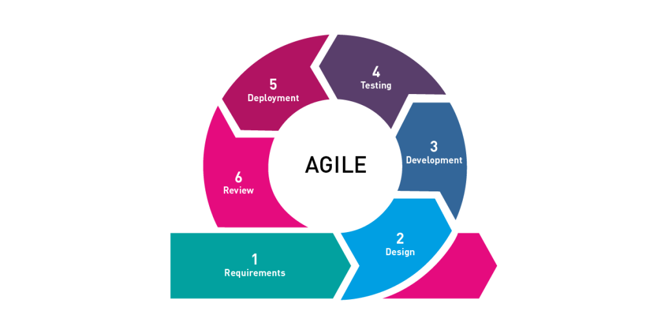

**Figure 2. Agile Software Development**

The **Agile** methodology focuses on providing value to end-users and prioritizes collaboration, flexibility, and continuous improvement. The model has five phases: Requirements, Design, Development, Testing, Deployment, and Review. The project utilizes AI algorithms to develop an effective job-matching system, including Hybrid Filtering, Collaborative Filtering, User-Based Content Filtering, and NLP algorithms.

**Software Life Cycle Model**

**Requirements Gathering**: In this phase, the researcher needs to identify the specific requirements for the software development project. One crucial requirement is the need for a large amount of data related to job postings, job requirements, job preferences, and alumni data. This data will be used to train and improve the AI algorithms used in the system, particularly Hybrid Filtering, Collaborative Filtering, User-Based Content Filtering, and NLP algorithms.

**Design**: In this phase, the overall design of the software is created, including the architecture, user interface, and database schema. The design should be capable of incorporating the AI algorithms identified in the previous phase, with appropriate data sources and integration of the algorithms to ensure good job matching.

**Development**: In the development phase, the project team will work with the datasets to develop and test the AI algorithms. The data will be used to train the algorithms to identify patterns and relationships between job postings and alumni data. The team will use techniques such as supervised and unsupervised learning to ensure that the algorithms can accurately match alumni with relevant job opportunities.

**Testing**: In this phase, the software is tested to ensure that it meets the requirements and is error-free. The AI Expert should test AI algorithms to ensure they function effectively and provide accurate job-matching results.

**Deployment**: The software is deployed to the production environment in this phase. The AI algorithms should be integrated and fully operational within the system, ready to provide job-matching services to alumni.

**Maintenance**: The software is maintained and updated as needed in this phase. The researcher should continuously monitor the AI algorithms to ensure they provide accurate job-matching results and update them as necessary to improve their performance.

**Data Gathering Procedure**

The proponent employed various data collection methods to acquire pertinent information to accomplish the proposed study's objectives. The following are the data collection methods used:

1. Observation. The researcher conducted observations to gather information regarding alumni and their job preferences and collect data on job postings and employer requirements.
2. Interview. The researcher interviewed the stakeholders, including alumni, employers, and the administrator, as they provided rich, detailed data on alumni's career goals, job preferences, skills, and experience. This data can be used to develop AI algorithms that provide personalized job recommendations and improve the overall effectiveness of the platform.
3. Internet Research. The researcher conducted online research to acquire supplementary information relevant to the study.
4. Survey questionnaire. The proponent distributed surveys to all system users, enabling them to provide feedback and express their needs and preferences regarding the developed system of the proponent.

**Data Analysis Procedure**

The collected data was subjected to analysis utilizing mean and grand mean calculations, accompanied by verbal explanations to interpret the outcomes.

**Validity of the Research Instrument**

The questionnaires underwent a comprehensive review and validation process conducted by three (3) experts, utilizing the Good and Scates tool for questionnaire validation and evaluation. The results revealed a grand mean of 4.79, which indicates that the questionnaires are deemed valid based on interpretation criteria.

**Reliability of the Research Instrument**

The self-made questionnaire was subjected to a reliability test with twenty (20) alumni in Barangay Old Sagay, Sagay City.

**Table 1.0**

**Reliability and Statistics**

|  |  |
| --- | --- |
| **Cronbach’s Alpha** | **N of items** |
| 0.809 | 18 |

Reliability, as defined by Babbie (2017), pertains to the consistency and stability of measurement or data collection methods, ensuring the ability to obtain similar results under consistent conditions. In order to assess reliability, a dry run was performed on a sample of 20 alumni from the school. The coefficient of correlation was determined using Cronbach Alpha.

Based on the calculation, the alpha coefficient obtained for the research instrument was 0.809 as shown in Table 1.0. According to DeVellis (2017), a coefficient of 0.7 or higher indicates a high level of reliability. Hence, it can be inferred that the researcher's developed research instrument exhibited a significant level of reliability.

**Context Flow Diagram**

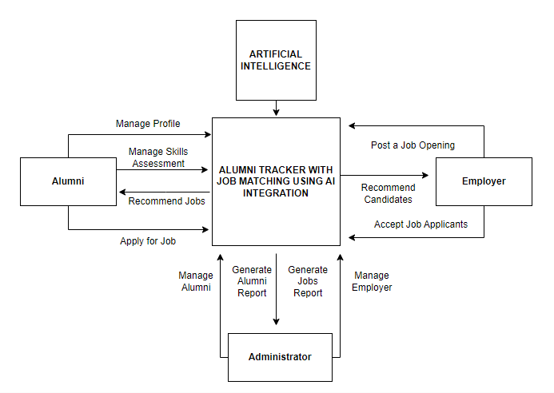

**Figure 3. Context Flow Diagram**

Figure 3 illustrates the researcher's depiction of how the complete features and components of the system will collaborate in alignment with its intended function. This figure has three main external entities: alumni, administrators, and employers. The integration of Artificial Intelligence.

**Data Flow Diagram**

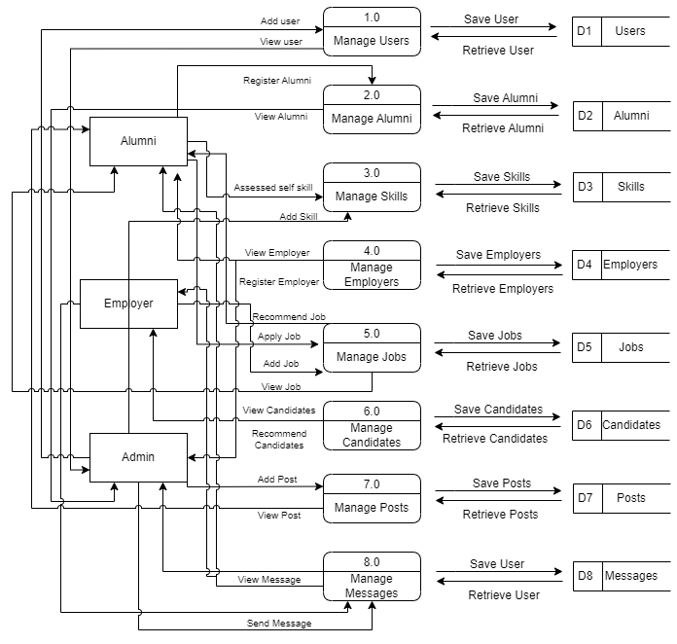

**Figure 4. Data Flow Diagram**

Figure 4 illustrates how information is processed within the system, including where it comes from, how it is transformed, and where it is stored. The purpose of the Data Flow Diagram is to depict the system's scope and boundaries, and it can be used as a tool for communication between the systems analyst and stakeholders involved in the system's redesign.

**Entity-Relationship Diagram**

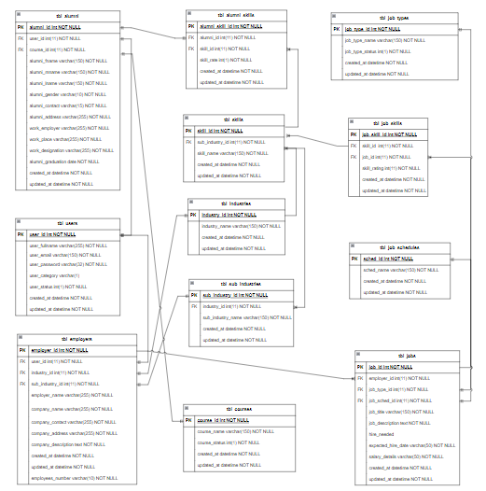

**Figure 5. Entity Relationship Diagram**

An ER diagram provides a visual depiction of the relationships between various entities, serving as a blueprint for your system architecture. It presents a snapshot of how these entities are interconnected, as demonstrated in Figure 5.

**Application Architecture**

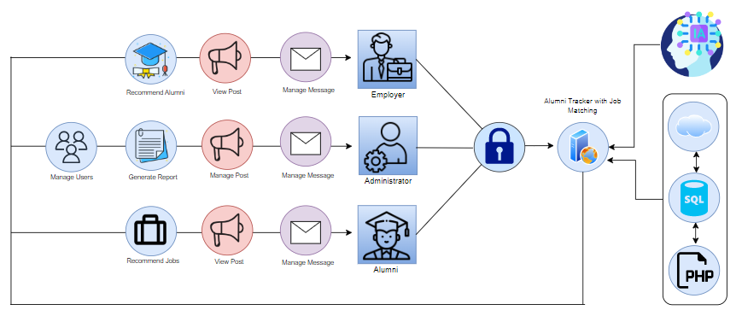

**Figure 6. Application Architecture**

Figure 6 showcases the operational dynamics of the system when utilized by registered users. In this architecture, the system is built around a web server, which serves as the entry point for incoming requests. The Job Portal component handles requests from alumni and job seekers, allowing them to view job postings and apply for relevant positions. The Job Matching Module processes incoming job applications and uses AI algorithms to match alumni with relevant job postings. The Alumni Tracker Module is responsible for managing the data and profiles of alumni, including their personal and professional information. The AI Engine component provides the computing resources needed to run the AI algorithms used in the system.

**Use-Case Diagram**

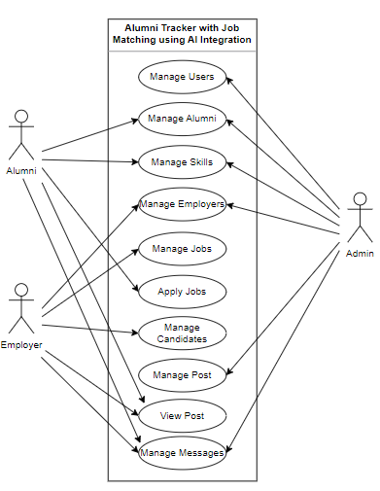

**Figure 7. Use Case Diagram**

Figure 7 illustrates a Use Case diagram, which serves as a visual representation of the interactions between a user and the system, showcasing the relationships between the user and the various use cases in which they are engaged.

**Software Requirements**

**Table 3.0**

**Software Specifications**

|  |  |
| --- | --- |
| **Requirement** | **Purpose** |
| ***Admin side:*** |  |
| Operating System | To run the administrative interface for the system. Example: Windows 7, 8, or 10 |
| PHP | To develop the server-side components of the system. |
| Web Hosting/Server | To host and deploy the system. Example: Apache or Nginx web server |
| MySQL | To manage the database of the system. |
| Python | To implement various features and algorithms of the system. |
| ***Client side:*** |  |
| Operating System | To run the client-side interface for the system. Example: Windows 7, 8, or 10 |
| Web Browser | To access the system's interface. Example: Google Chrome, Mozilla Firefox |

Table 3.0 presents the software requirements needed in order to operate the program properly.

**Table 4.0**

**Hardware and Other Required Devices**

|  |  |
| --- | --- |
| **Requirement** | **Purpose** |
| ***Hardware and Other Required Devices:*** |  |
| Processor | To handle the computational load of the system. Example: Intel Core i3 or higher |
| RAM | To provide memory resources to run the system efficiently. Example: 2GB or higher |
| Hard Disk Drive | To store the system's files and data. Example: 500GB or higher |
| Printer | To print documents generated by the system. |
| Internet Plan | To ensure the system has a stable and reliable internet connection. Example: at least 5 Mbps |

This section presents the hardware resources needed for the study. The hardware and other required devices are presented in Table 4.

**Cost-Benefit Analysis**

**Table 5.0**

**Developmental Cost**

|  |  |  |  |
| --- | --- | --- | --- |
| **Development Cost** | **Duration** | **Cost** | **Total Amount** |
| Programmer | 2 months | 20,000 | 20,000 |
| System Analyst | 2 months | 20,000 | 20,000 |
| AI Expert | 2 months | 30,000 | 30,000 |
| Computer set 3 |  | 20,000 | 60,000 |
| Internet Fee | 2 months | 1,299 | 2,598 |
| **Subtotal** |  |  | 132,598 |

Table 5.0 shows the system's developmental cost, including the programmer fee, system analyst fee, AI Expert, price of computer set, and internet fee, which accumulated to 132,598.

**Table 6.0**

**Operational Cost**

|  |  |  |  |
| --- | --- | --- | --- |
| **Operational Cost** | **Duration** | **Cost** | **Total Amount** |
| Electrical Expense | 12 months | 1,000 | 12,000 |
| Internet Fee | 12 months | 1,299 | 15,588 |
| Maintenance Fee | 12 months | 1,500 | 18,000 |
| Cloud server (Hostinger VPS Server Plan 4) | 12 months | 1,629 per month | 19,548 |
| Computer set |  | 20,000 | 20,000 |
| Printer |  | 5,000 | 5,000 |
| **Subtotal** |  |  | **90,136** |

Table 6.0 shows the system's operational cost, including electrical expenses, internet fees, maintenance fees, cloud servers, computer sets, and printers of alumni administrators, which accumulated to 90,136.

**Table 7.0**

**Total Developmental and Operational Cost**

|  |  |
| --- | --- |
|  | **Total Cost** |
| Developmental Cost | 132,598 |
| Operational Cost | 90,136 |
| **Total** | **222,734** |

Table 7.0 shows the total developmental and operational cost of 222,734.

**Table 8.0**

**Benefits of the system**

|  |  |  |  |
| --- | --- | --- | --- |
| **Benefits of the system** | **Duration** | **Cost** | **Total Amount** |
| Improved Job Matching | 12 months | 9,000 | 108,000 |
| Increased Alumni Engagement | 12 months | 6,000 | 72,000 |
| Improved Career Outcomes | 12 months | 8,000 | 96,000 |
| Security of data | 12 months | 3,000 | 36,000 |
| Data backup | 12 months | 4,000 | 48,000 |
| **Total cost benefit** |  |  | **360,000** |

Table 8.0 shows the system's total cost benefit, including improved job matching, increased alumni engagement, improved career outcomes, security of data, and data backup, which accumulated to 360,000.

**CHAPTER IV**

**PRESENTATION, ANALYSIS, AND INTERPRETATION OF DATA**

After the comprehensive evaluation involving experts and respondents, the following are discovered:

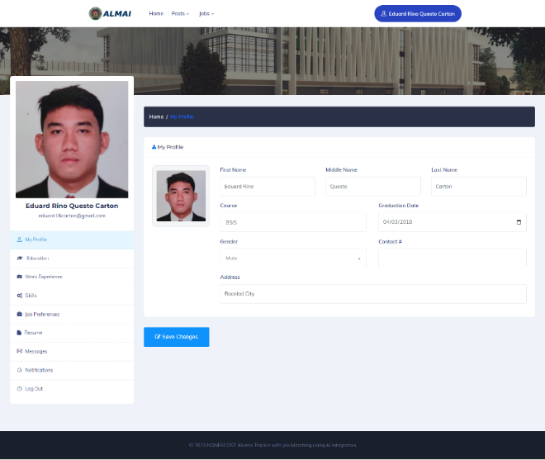

**Figure 8. Alumni’s Profiles**

Figure 8 shows how the alumni can manage their own profiles on the Alumni Tracker with Job Matching using AI Integration. The alumni can update his personal records, which generates an Alumni report.

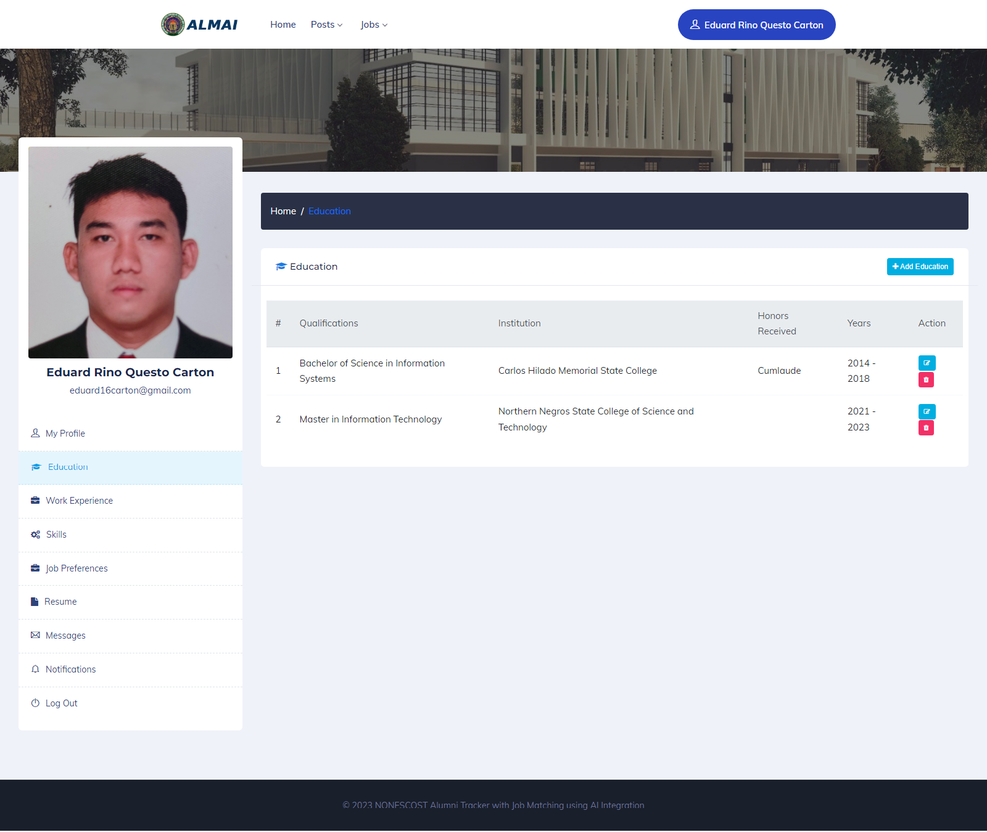

**Figure 9. Alumni’s Education**

Figure 9 depicts how alumni can autonomously manage their education history using the Alumni Tracker with Job Matching, which incorporates AI integration. This system allows alumni to add and manage their education details, including the school attended, program undertaken, honors received, and graduation year. Consequently, employers can access and review the candidate's education history.

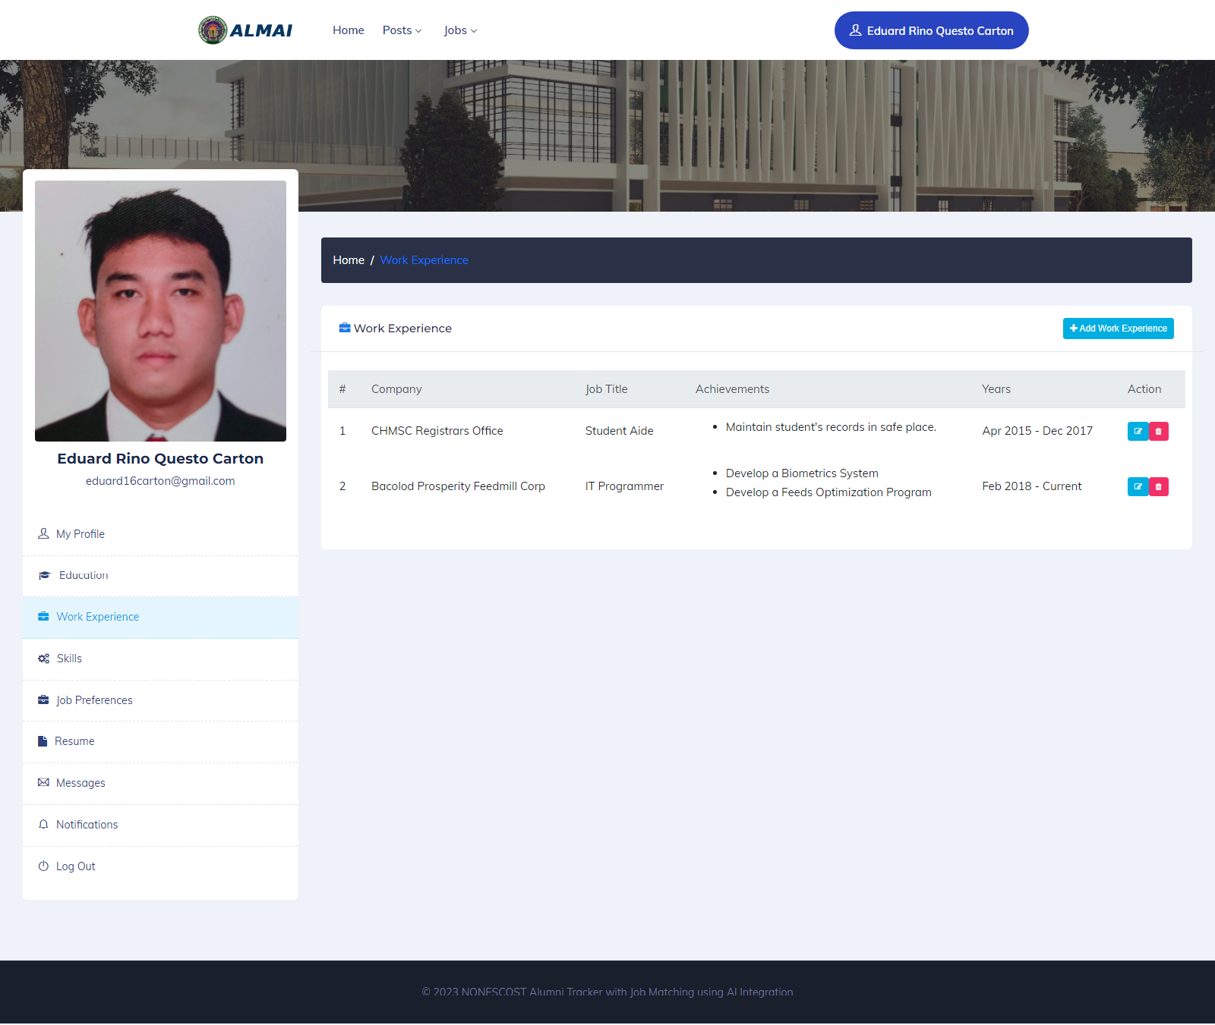

**Figure 10. Alumni’s Work Experience**

Figure 10 illustrates how alumni can independently manage their work experience history within the Alumni Tracker with Job Matching, incorporating AI Integration. Using this system, alumni can add and manage their work experience, including details such as the company name, job title, duration of employment, and notable achievements. As a result, employers can review the candidate's work and experience history.

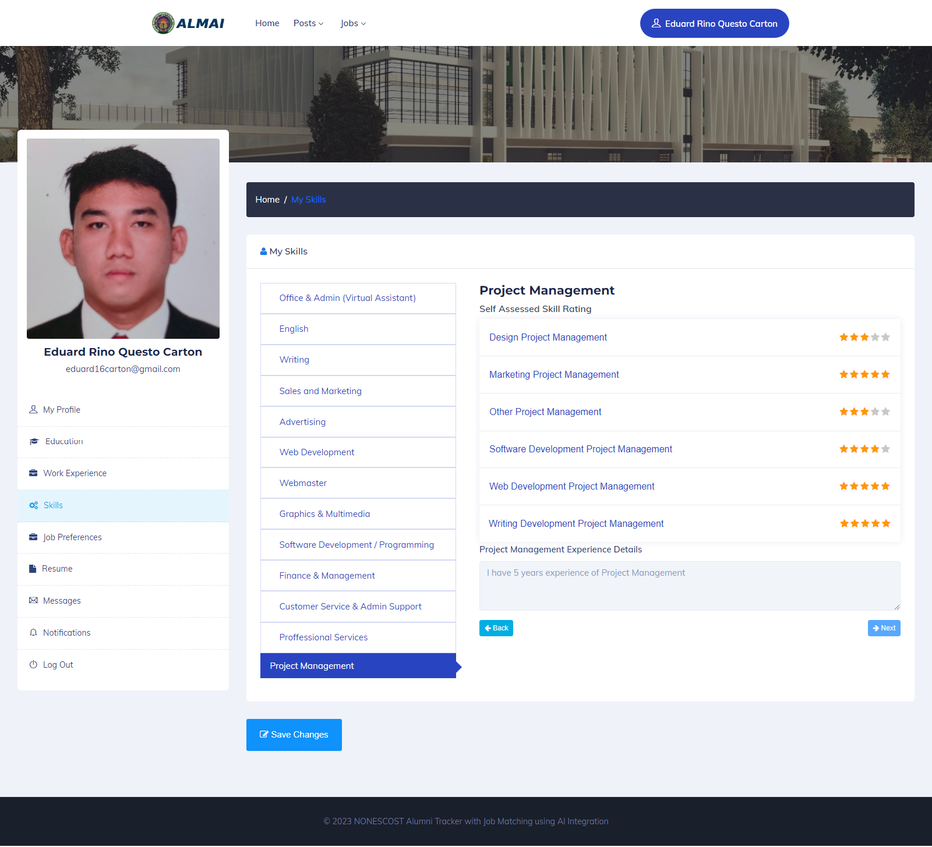

**Figure 11. Alumni’s Skills Assessment**

Figure 11 demonstrates how alumni can evaluate their skills within the Alumni Tracker with Job Matching, leveraging AI Integration. In this system, alumni can assess their skills based on predefined mastery levels, including novice, intermediate, proficient, advanced, and expert. This self-assessment allows alumni to gauge their skill levels accurately.

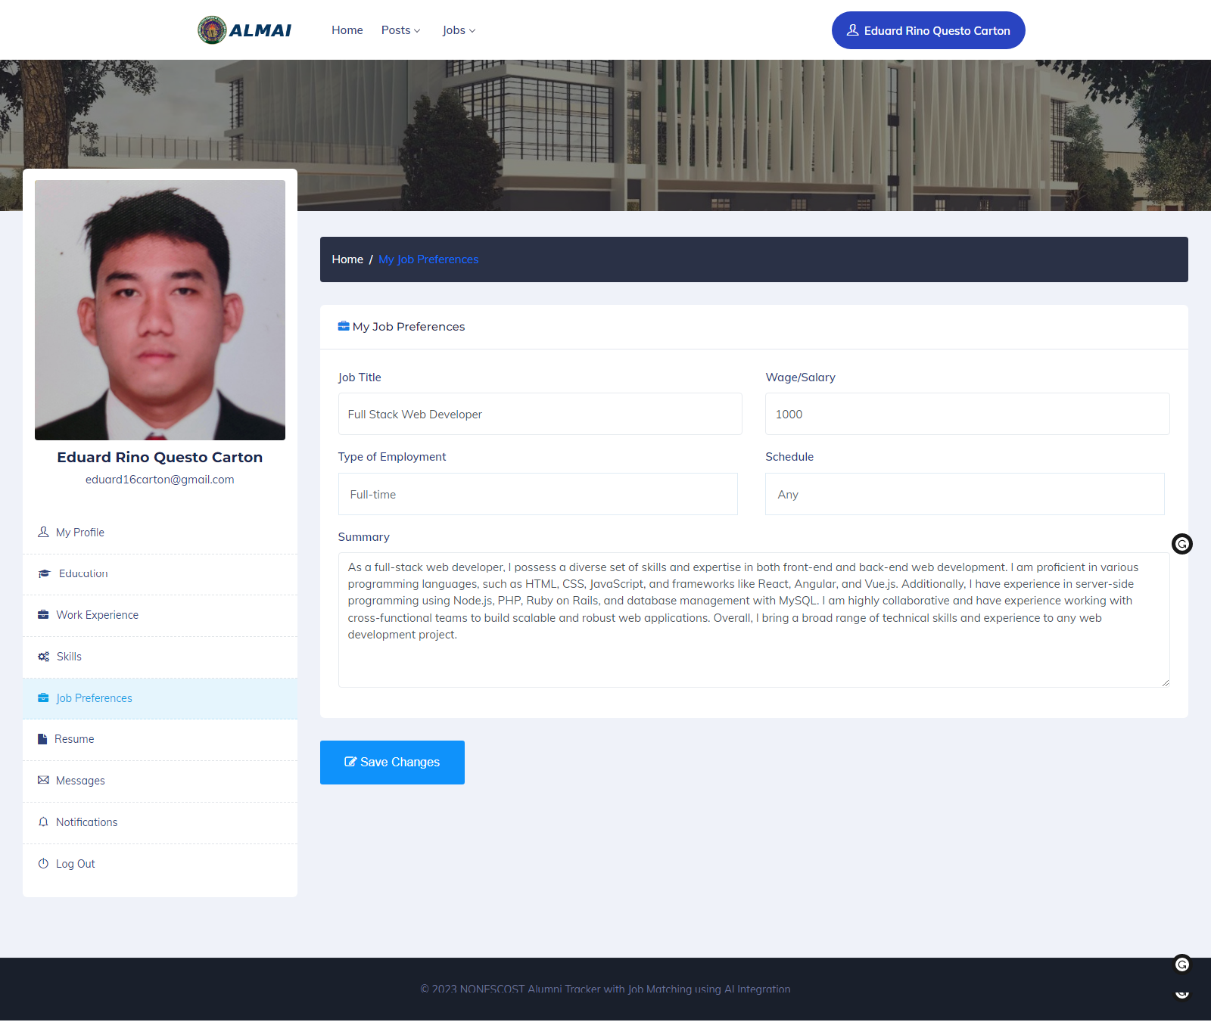

**Figure 12. Alumni’s Job Preferences**

Figure 12 depicts how alumni can control their job preferences within the Alumni Tracker with Job Matching, utilizing AI Integration. In this system, alumni can add and manage their job preferences, specifying details such as the desired job title, salary expectations, preferred type of employment, chosen job schedule, and a summary of their skills and experiences. This functionality allows alumni to tailor their job preferences to align with their career aspirations.

**Table 9.0**

**In terms of managing NONESCOST Alumni’s data.**

|  |  |  |
| --- | --- | --- |
|  | **Mean** | **Verbal Interpretation** |
| The system can manage alumni’s profiles. | 4.44 | Very Good |
| The system can manage alumni’s education | 4.25 | Very Good |
| The system can manage alumni’s work experience | 4.3 | Very Good |
| The system can manage alumni’s skills assessment | 4.55 | Very Good |
| The system can manage alumni’s job preferences | 4.3 | Very Good |
| **Total** | **4.36** | **Very Good** |

The outcome of the users' feedback on the Alumni Tracker with Job Matching, incorporating AI Integration, is presented in Table 9.0. The feedback indicates that the system allows alumni to utilize and access it effectively and manage their profiles, education history, work experience, skills assessment, and job preferences. The feedback was rated with a mean value of 4.36, indicating a "Very Good" interpretation.

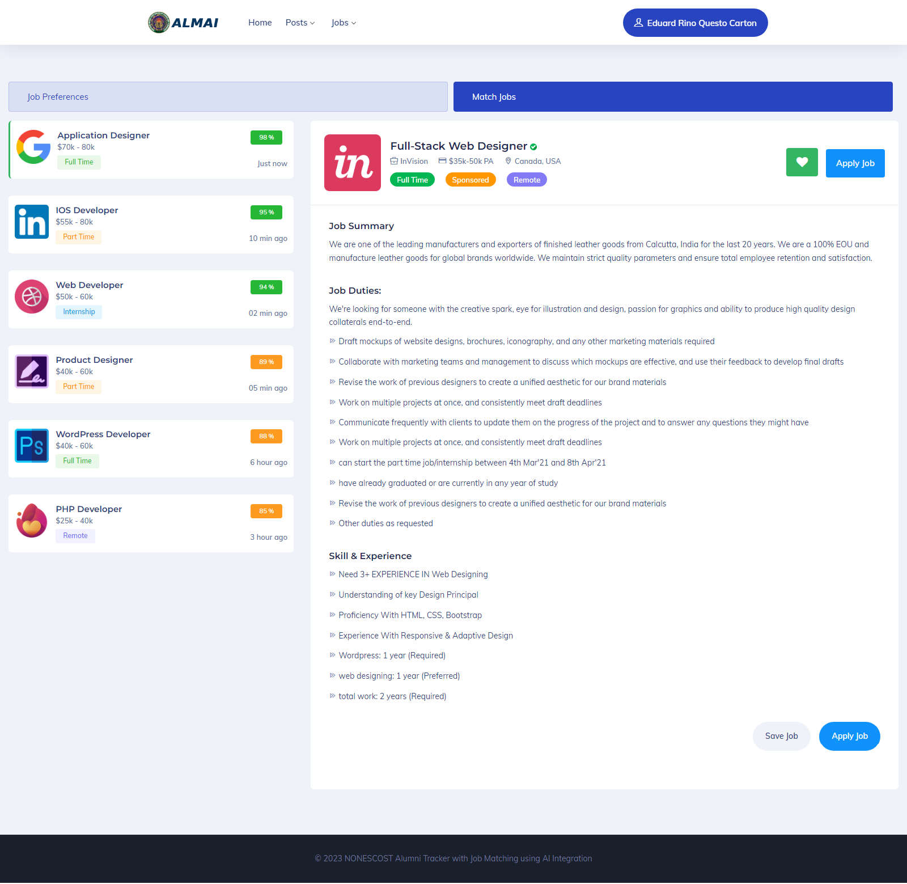

**Figure 13. Alumni’s Job Matching**

Figure 13 illustrates Alumni matched jobs within the Alumni Tracker with Job Matching, utilizing AI Integration. Alumni can access this feature to view job opportunities that align with their job preferences. The matched jobs are presented with a percentage indicator, indicating the compatibility between the alumni's preferences and the job requirements.

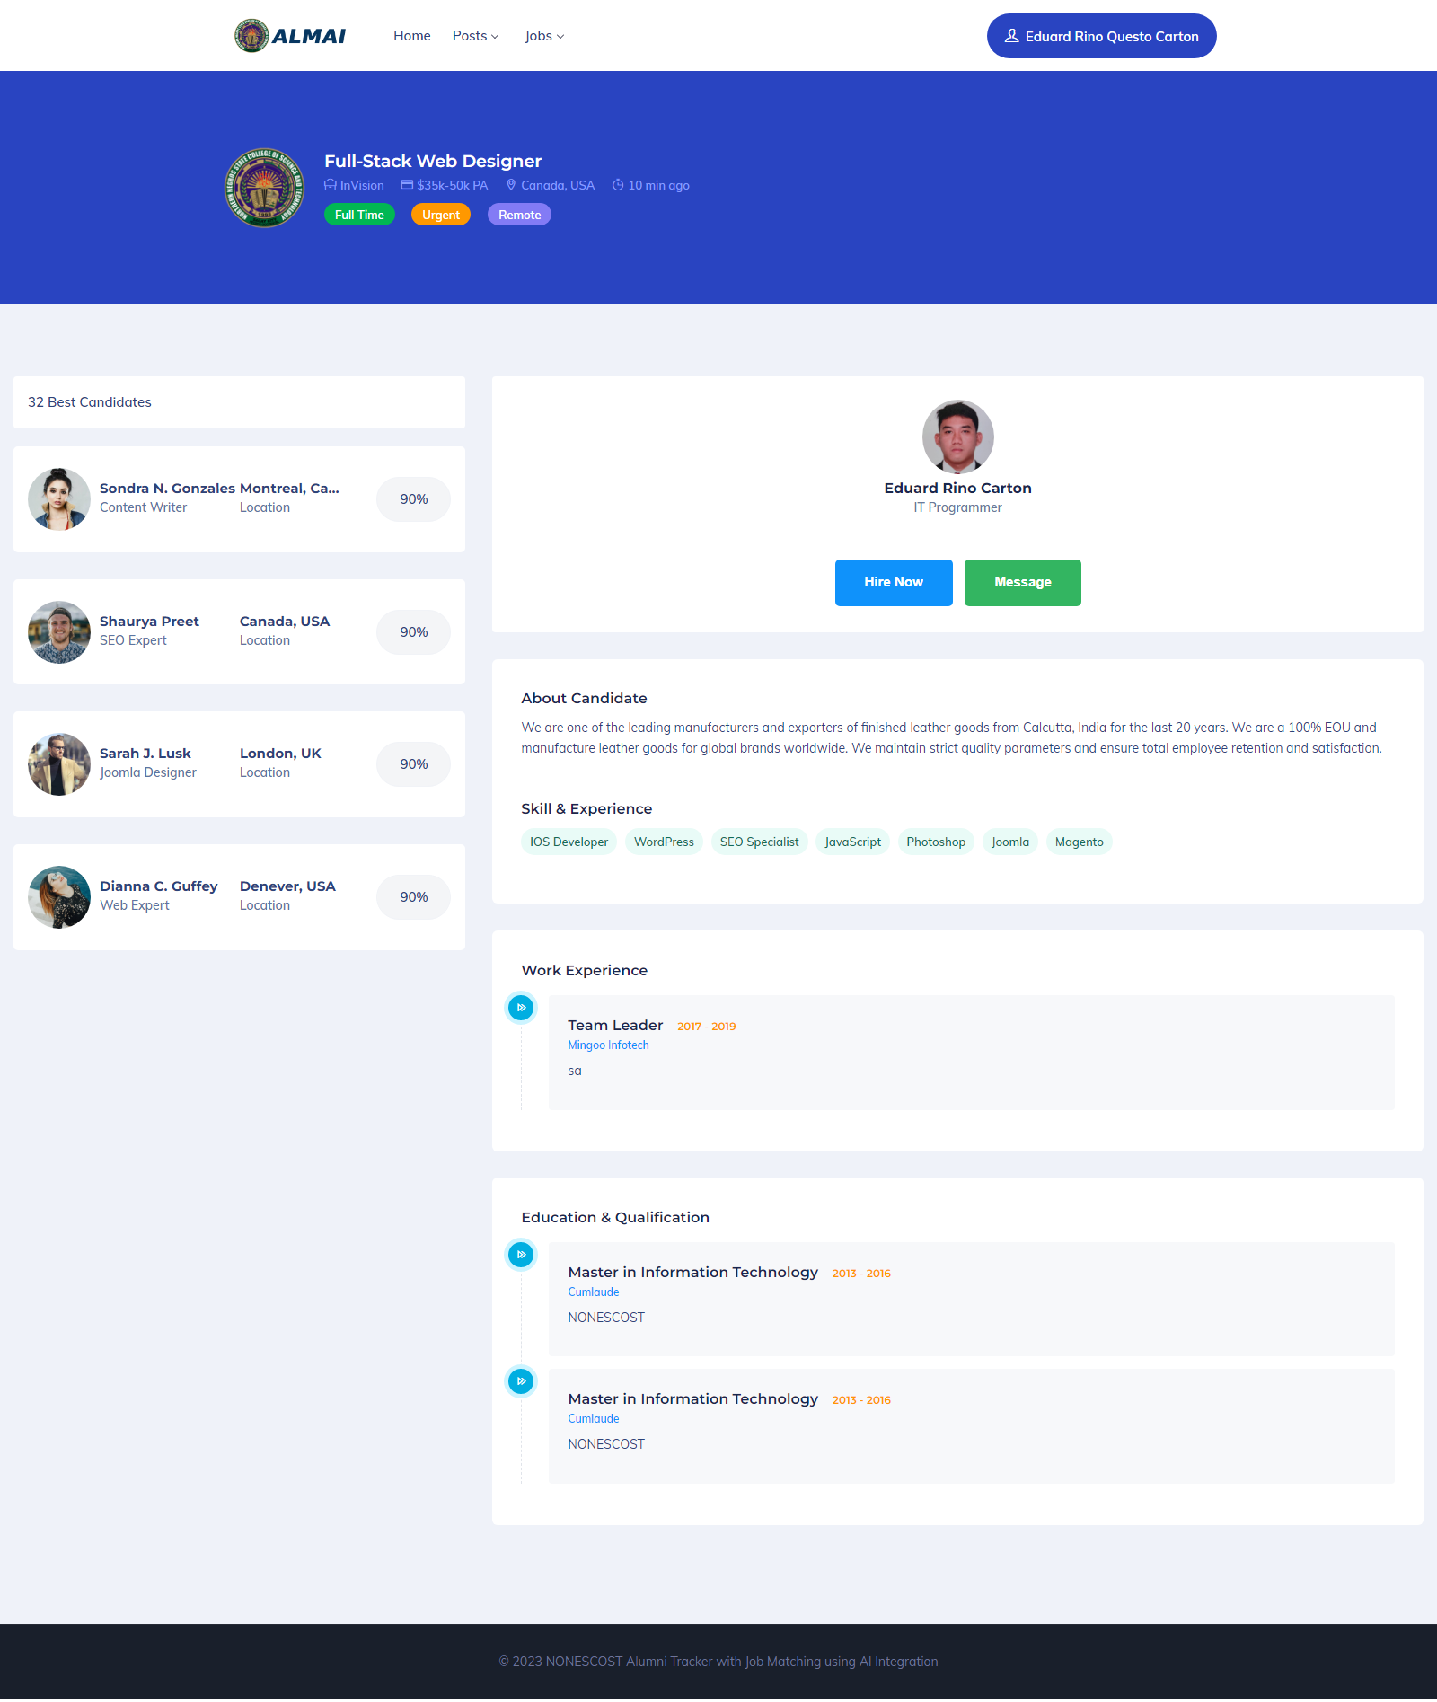

**Figure 14. Job’s Best Candidate**

Figure 14 showcases the presentation of the best candidates for a job within the Alumni Tracker with Job Matching, leveraging AI Integration. Employers can utilize this feature to view alumni who closely match the job preferences specified for a particular position. The matched candidates are displayed along with a percentage indicator, denoting the level of alignment between the alumni's skills and experiences and the job requirements.

**Table 10.0**

**In terms of integrating AI using the Job Matching Algorithm to provide personalized job recommendations.**

|  |  |  |
| --- | --- | --- |
|  | **Mean** | **Verbal Interpretation** |
| The system can recommend best jobs for alumni | 4.5 | Very Good |
| The system can recommend best candidates for the job | 4.2 | Very Good |
| **Total** | **4.35** | **Very Good** |

The feedback from users on the Alumni Tracker with Job Matching, incorporating AI Integration, is presented in Table 10.0. The feedback indicates that the system enables alumni to effectively utilize and access it, view the best jobs that align with their preferences, and allow employers to view the best candidates. The system's feedback received a mean rating of 4.35, which is interpreted as "Very Good."

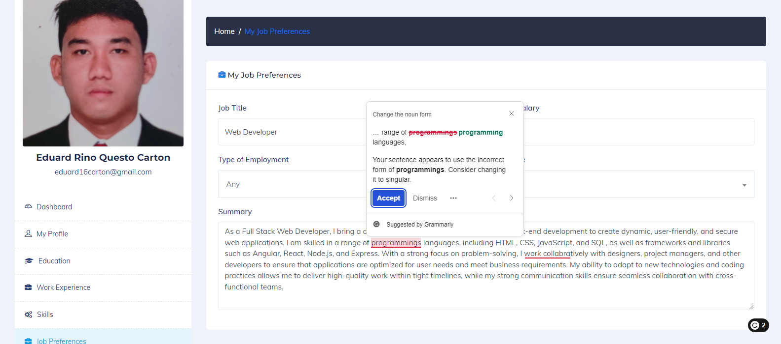

**Figure 15. Alumni Job Preferences with AI**

Figure 15 depicts the presentation of alumni job preferences with AI within the Alumni Tracker with Job Matching, incorporating AI Integration. Alumni can manage their job preferences using this system, and it also utilizes Natural Language Processing to analyze text and offer suggestions. This feature assists alumni in refining their job preferences and optimizing their job search experience.

**Table 11.0**

**In terms of integrating AI using Natural Language Processing (NLP) Algorithms to analyze text and provide suggestions.**

|  |  |  |
| --- | --- | --- |
|  | **Mean** | **Verbal Interpretation** |
| The system can analyze text spelling errors and suggest corrections. | 4.55 | Very Good |
| The system can analyze text for grammar errors and provide suggestions for corrections | 4.2 | Very Good |
| **Total** | **4.38** | **Very Good** |

The feedback from users on the Alumni Tracker with Job Matching, incorporating AI Integration, is shown in Table 11.0. The feedback indicates that the system effectively provides access and usability for alumni, employers, and admins, allowing them to view the analyzed text and suggestions generated by AI. The system received an overall rating of 4.38, which is interpreted as "Very Good."

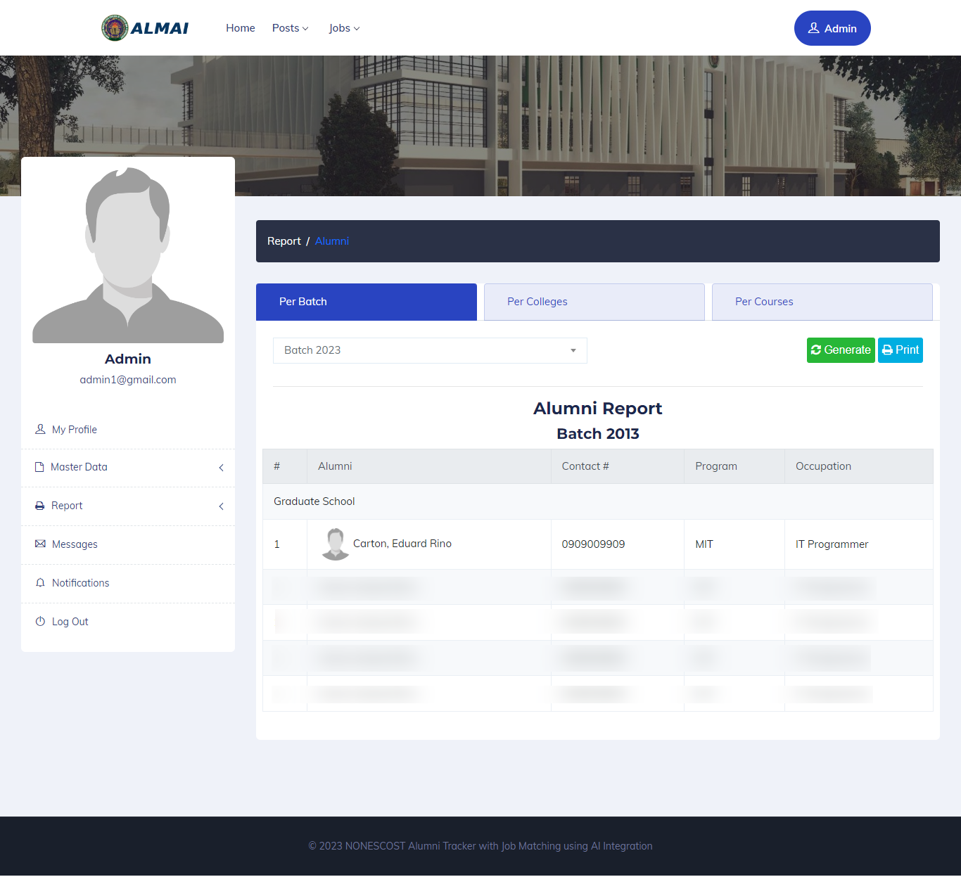

**Figure 16. Alumni Report per Batch**

Figure 16 illustrates the generation of an alumni report per batch within the Alumni Tracker with Job Matching, incorporating AI Integration. The admin can generate a comprehensive report for each batch of alumni. The report includes essential details such as the alumni's name, contact number, email address, program of study, and current occupation. This feature enables efficient tracking and management of alumni information for administrative purposes.

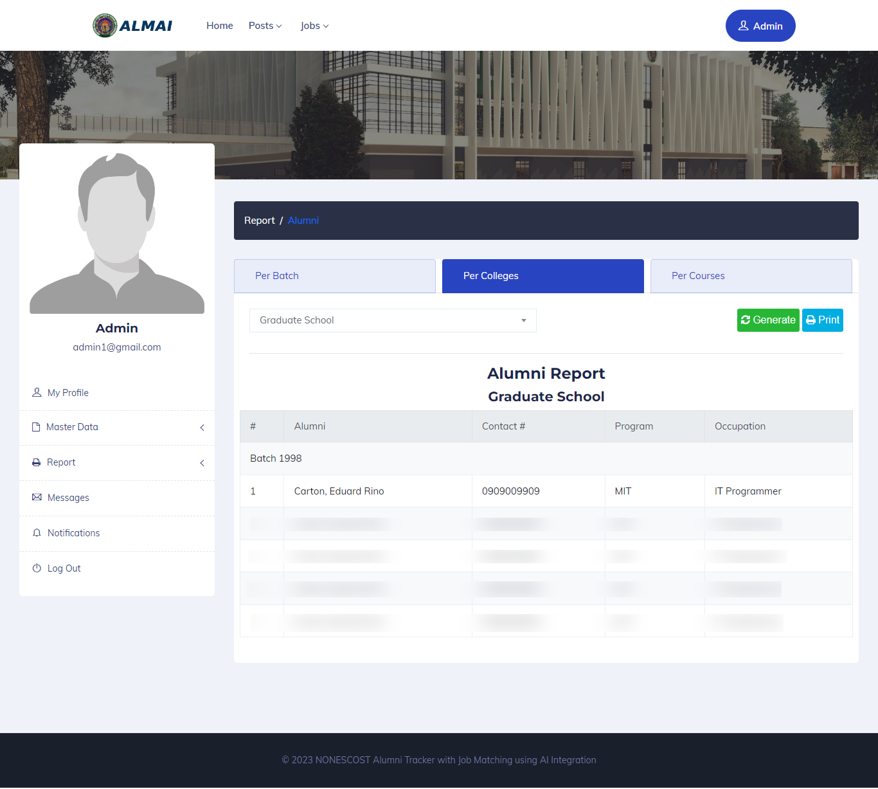

**Figure 17. Alumni Report per College**

Figure 17 visually represents the generation of an alumni report per college within the Alumni Tracker with Job Matching, incorporating AI Integration. The admin can produce a comprehensive report specific to each college. This report includes crucial information such as the alumni's name, contact number, email address, program of study, and current occupation. This feature facilitates efficient tracking and management of alumni information on a per-college basis for administrative purposes.

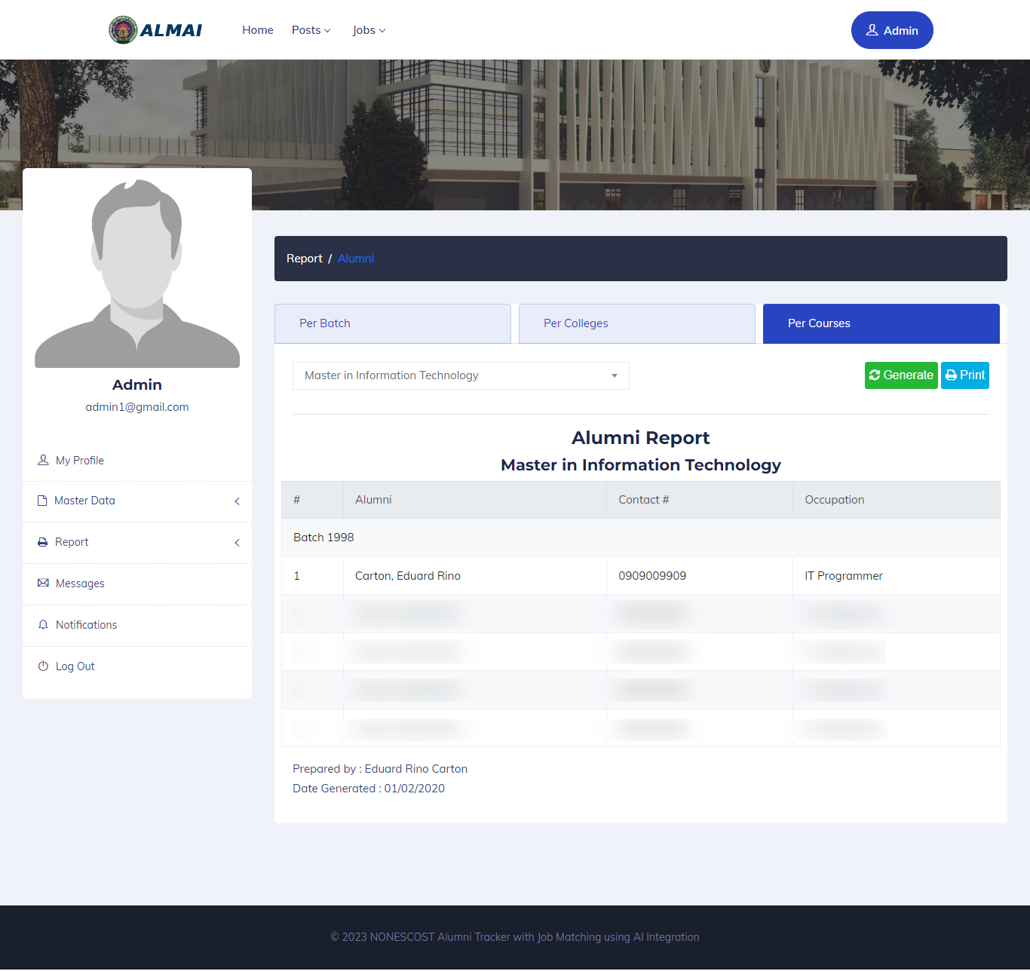

**Figure 18. Alumni Report per Courses**

Figure 18 displays the generation of an alumni report per course within the Alumni Tracker with Job Matching, leveraging AI Integration. The admin can generate a comprehensive report specific to each course. This report includes vital details such as the alumni's name, contact number, email address, and current occupation. This feature facilitates effective tracking and managing of alumni information per course for administrative purposes.

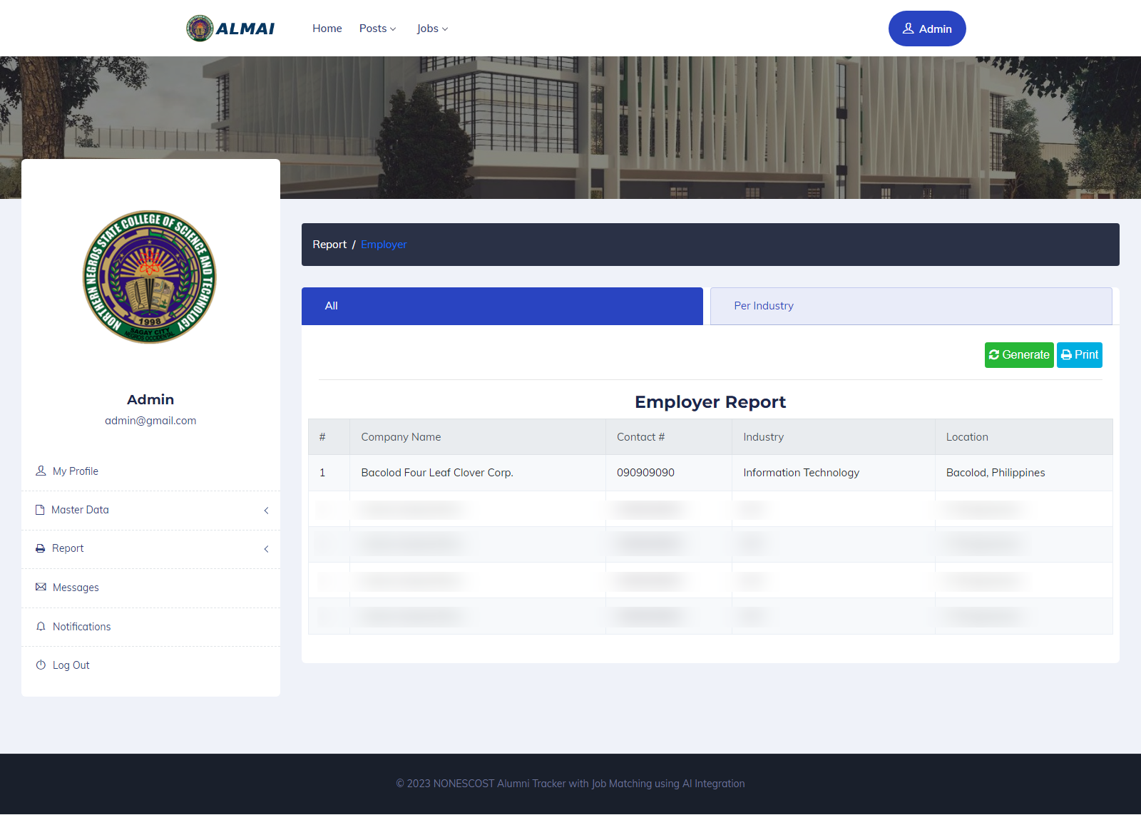

**Figure 19. Employer Report**

Figure 19 represents the generation of an employer report within the Alumni Tracker with Job Matching, incorporating AI Integration. The admin can generate a comprehensive report specific to employers. This report includes essential information such as the company name, contact number, email address, and industry. This feature facilitates efficient tracking and management of employer information for administrative purposes.

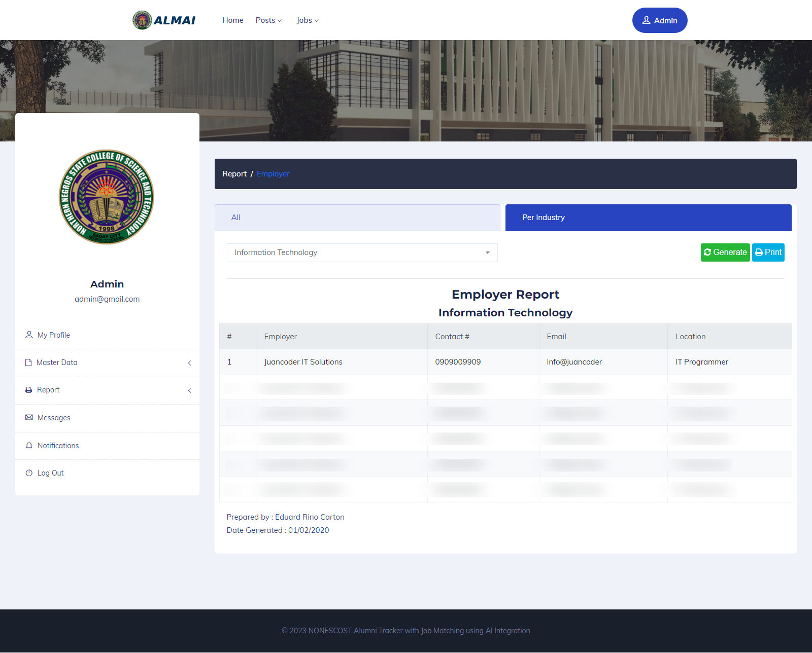

**Figure 20. Employer Report per Industry**

Figure 20 visually demonstrates the generation of an employer report per industry within the Alumni Tracker with Job Matching, leveraging AI Integration. The admin can produce a comprehensive report specific to each industry. This report includes essential details such as the company name, contact number, and email address. This feature enables efficient tracking and management of employer information per-industry basis for administrative purposes.

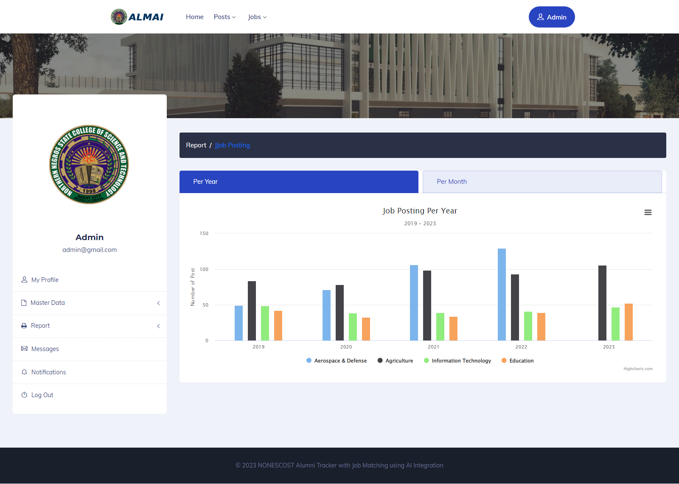

**Figure 21. Job Posting Report per Year**

Figure 21 represents the generation of an annual job posting report within the Alumni Tracker with Job Matching, incorporating AI Integration. The admin can generate a graphical report in the form of a basic column chart specific to each year. This report showcases the number of job postings made each year, visually representing the data. This feature aids in analyzing the trends and patterns of job postings over time.

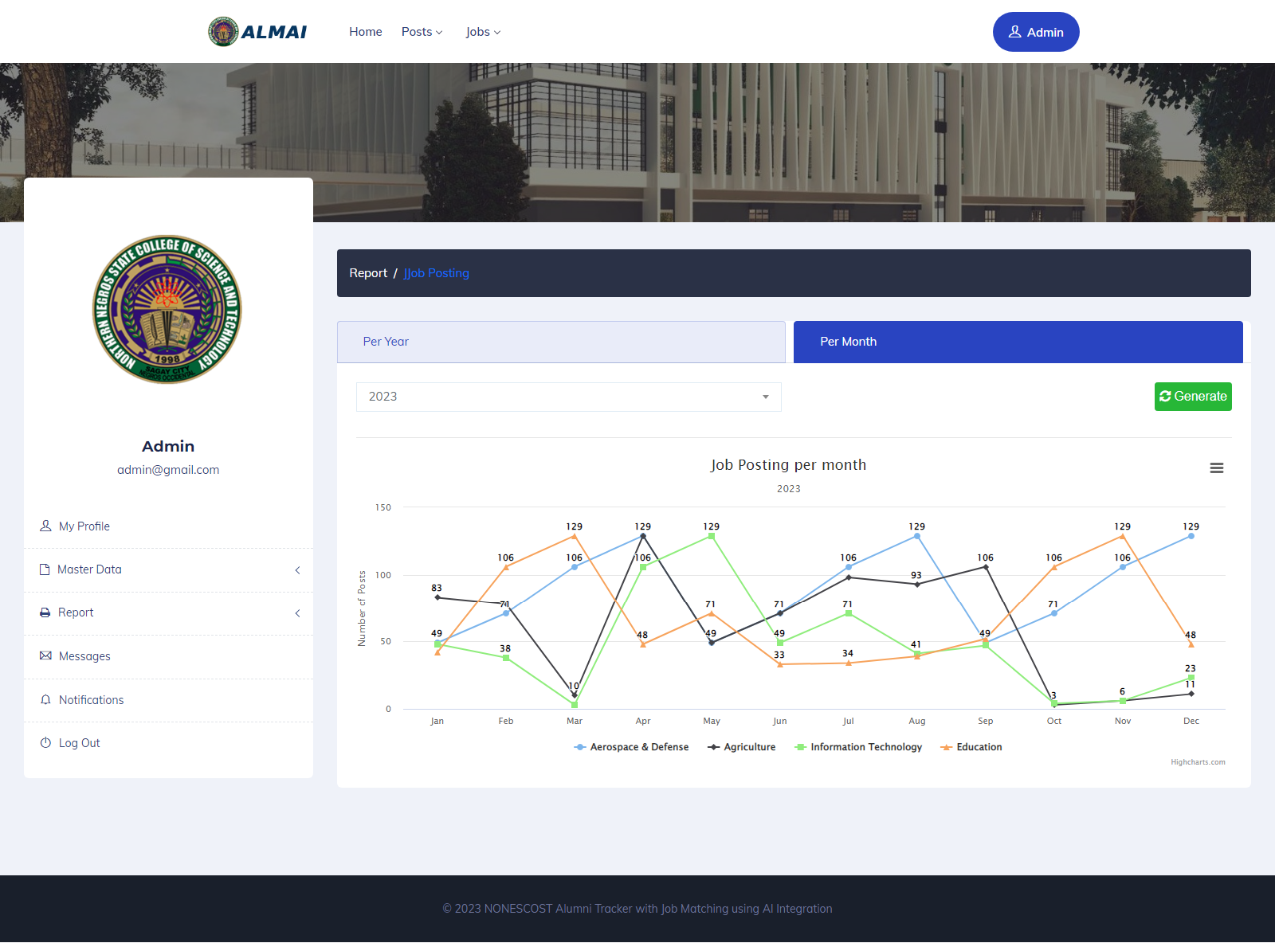

**Figure 22. Job Posting Report per month**

Figure 22 visually presents the generation of a job posting report per month within the Alumni Tracker with Job Matching, incorporating AI Integration. The admin can generate a graphical report as a primary line chart specific to each month. This report showcases the number of monthly job postings, providing a visual representation of the data. This feature aids in analyzing the monthly fluctuations and trends in job postings, offering valuable insights into the job market dynamics.

**Table 12.0**

**In terms of generating a report**

|  |  |  |
| --- | --- | --- |
|  | **Mean** | **Verbal Interpretation** |
| The system can generate alumni report per batch | 4.55 | Very Good |
| The system can generate alumni report per college | 4.15 | Very Good |
| The system can generate alumni report per course | 4.25 | Very Good |
| The system can generate employer report per industry | 4.25 | Very Good |
| The system can generate employment rate report by batch | 4.2 | Very Good |
| The system can generate employment rate report by college | 4.45 | Very Good |
| The system can generate employment rate report by course | 4.25 | Very Good |
| The system can generate a job posting report per year | 3.9 | Good |
| The system can generate a job posting report per month | 3.85 | Good |
| **Total** | **4.21** | **Very Good** |

The feedback from users on the Alumni Tracker with Job Matching, incorporating AI Integration, is presented in Table 12.0. The feedback indicates that the system effectively equips access and usability for the admin, enabling them to generate reports for alumni per batch, alumni per college, alumni per program, employer per industry, job posting per year, and job posting per month. The system received an overall rating of 4.21, which is interpreted as "Very Good."

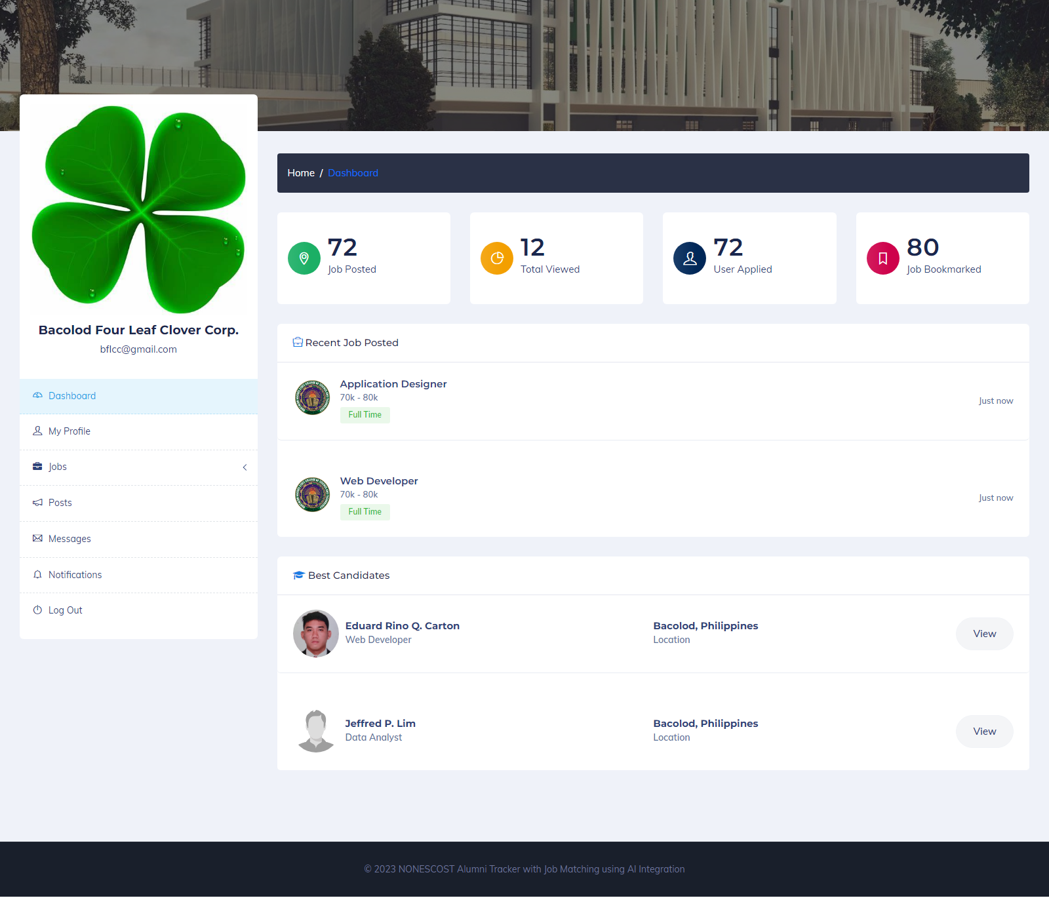

**Figure 23. Employer Dashboard**

Figure 23 visually represents the employer dashboard within the Alumni Tracker with Job Matching, incorporating AI Integration. This dashboard provides the employer various navigational options to access different features and functionalities. Additionally, the dashboard displays essential statistics such as the number of jobs posted, total views of jobs posted, the total number of candidates, and the total count of jobs bookmarked. These metrics offer valuable insights into the employer's recruitment activities and the engagement level of candidates with the posted jobs.

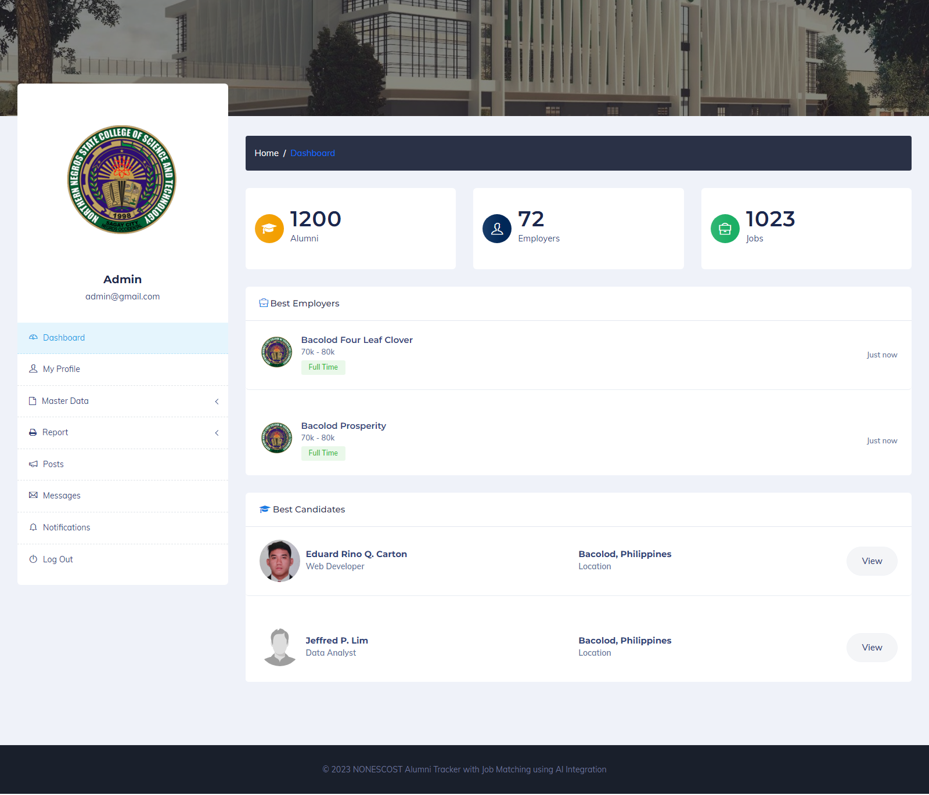

**Figure 24. Admin Dashboard**

Figure 24 visually represents the admin dashboard within the Alumni Tracker with Job Matching, incorporating AI Integration. This dashboard provides the admin various navigational options to access different features and functionalities. Additionally, the dashboard displays essential statistics such as the total number of alumni, the total number of employers, and the total number of jobs posted. These metrics offer a comprehensive overview of the system's usage and activity, enabling the admin to monitor and manage alumni and employer engagement effectively.

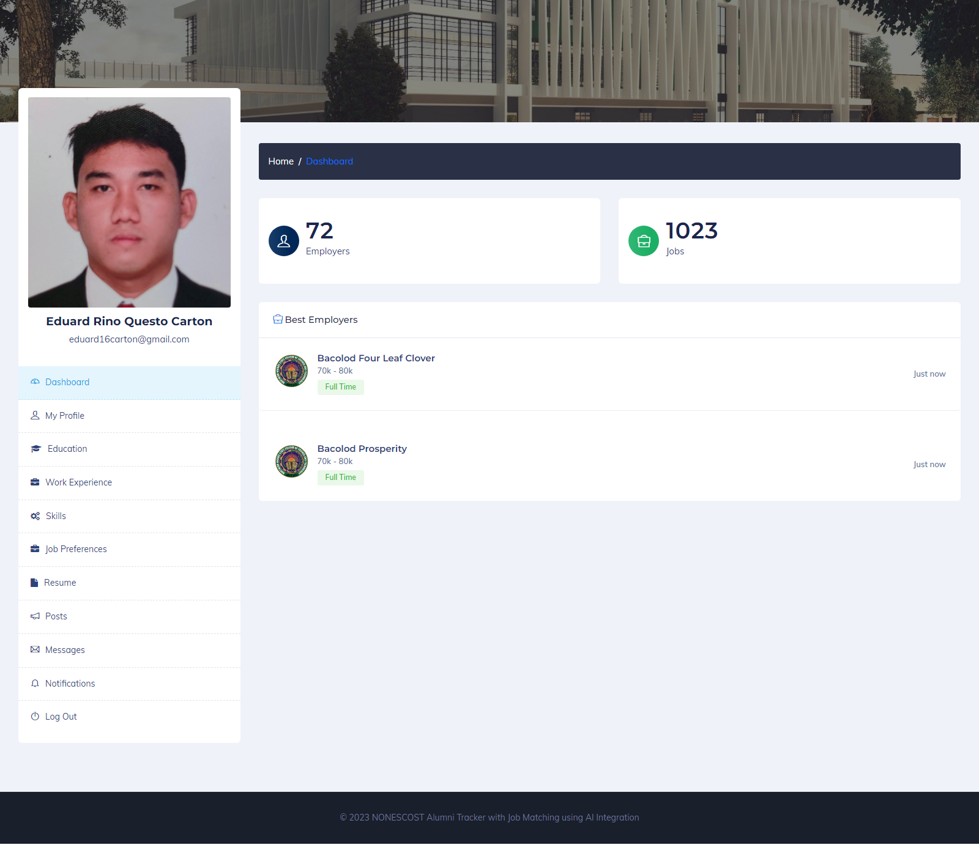

**Figure 25. Alumni Dashboard**

Figure 25 visually represents the alumni dashboard within the Alumni Tracker with Job Matching, incorporating AI Integration. This dashboard provides the alumni various navigational options to access different features and functionalities. Additionally, the dashboard displays essential information, such as the number of employers and the number of jobs posted. These metrics provide alumni insights into the opportunities available and employer engagement within the system, enhancing their job search and networking experience.

**Table 13.0**

**In terms of the characteristics set in ISO 25010 Software Quality Model**

|  |  |  |
| --- | --- | --- |
| **Criteria** | **Mean** | **Verbal Interpretation** |
| Functional Suitability | 5 | Very Good |
| Performance Efficiency | 5 | Very Good |
| Compatibility | 4.66 | Very Good |
| Usability | 4.33 | Good |
| Reliability | 5 | Very Good |
| Security | 4.66 | Very Good |
| Maintainability | 5 | Very Good |
| Portability | 4.66 | Very Good |
| **Total** | **4.79** | **Very Good** |

Table 13.0 presents the feedback from IT experts, evaluating the quality of the NONESCOST Alumni Tracker with Job Matching using AI Integration based on the characteristics defined in the ISO 25010 Software Quality Model.

In terms of Functional Suitability, Performance Efficiency, Reliability, and Maintainability, it received a mean value rating of 5, indicating a "Very Good" level. Similarly, it achieved a mean value rating of 4.66, also classified as "Very Good", for Compatibility, Security, and Portability. However, in terms of Usability, it received a mean value rating of 4.33, which denotes a "Good" level of usability.

In terms of Functional Suitability, the Alumni Tracker with Job Matching using AI Integration provides a wide range of functionalities that allow educational institutions to monitor the career development of alumni, provide career resources, and gather data to enhance the efficacy of programs and services while maintaining alumni engagement. The integration of AI algorithms in the development of the system enables alumni to find personalized job recommendations based on their skills and qualifications.

In terms of Performance efficiency, the system uses AI algorithms to analyze alumni data and provide personalized job recommendations, ensuring that job seekers find opportunities that match their qualifications and skills. The system's efficient algorithms ensure that the job recommendation process is fast and accurate, enabling alumni to find job opportunities quickly.

In terms of security, the system ensures the security of alumni data by using encryption and secure servers to protect the data. Additionally, the system requires authentication to access sensitive information, ensuring that only authorized users can access the data.

The reliability of Alumni Tracker with Job Matching using AI Integration is guaranteed through AI algorithms that provide accurate and personalized job recommendations while also allowing for bug reporting. The user-friendly interface and up-to-date information provided to alumni ensure the system meets the usability criterion. The system's use of AI algorithms also ensures maintainability, allowing developers to update the system to adapt to changes in the job market. Additionally, the system is highly portable and compatible with different web browsers and operating systems, meeting the portability and compatibility criteria, respectively.

**CHAPTER V**

**SUMMARY, CONCLUSION, AND RECOMMENDATIONS**

**Summary of Findings**

Based on the comprehensive analysis and interpretation of research findings, the summary of the ratings for different aspects of the Alumni Tracker with Job Matching using AI Integration is as follows:

1. In terms of managing NONESCOST Alumni’s data received a mean value rating of 4.51, indicating a "Very Good" level of performance.
2. In terms of integrating AI with the Job Matching Algorithm to provide personalized job recommendations received a mean value rating of 4.53, denoting a "Very Good" outcome.
3. In terms of integrating AI with the Natural Language Processing (NLP) Algorithm to analyze text and provide suggestions received a mean value rating of 4.56, indicating a "Very Good" outcome.
4. In terms of generating reports received a mean value rating of 4.56, also classified as a "Very Good" result.
5. In terms of determining the quality of the Alumni Tracker with Job Matching using the ISO 25010 Software Quality Model received a mean value rating of 4.69, representing a "Very Good" level of performance.

**Conclusion**

In conclusion, the study's findings indicate that the incorporation of AI into the Alumni Tracker system for NONESCOST has demonstrated remarkable effectiveness and significant benefits.The evaluation conducted by both experts and respondents confirms the system's ability to successfully manage alumni data, offer personalized job recommendations through AI job matching and NLP algorithms, and generate comprehensive reports for various stakeholders. The system's performance has been consistently rated as very good, reflecting its reliability, usability, maintainability, portability, and compatibility according to the ISO 25010 software quality model.

These results have significant implications for NONESCOST and its alumni community. The Alumni Tracker with Job Matching using AI Integration has the potential to enhance the connection between the institution and its alumni, facilitating seamless communication and engagement. Furthermore, the system empowers employers by providing an efficient platform to identify and connect with qualified candidates, thereby increasing the likelihood of successful job placements for alumni.

**Recommendation**

Based on the findings and conclusions, the following recommendations are proposed:

1. The Alumni Tracker with Job Matching using AI Integration should be implemented in other educational institutions across the Philippines to leverage its benefits and enhance alumni tracking and job matching capabilities.
2. Improve the notification mechanism to ensure timely and relevant communication between alumni, employers, and the system. This includes notifying alumni about matched job opportunities, notifying employers about the best candidate matches, and keeping all parties informed about important announcements.
3. Further, to enhance the effectiveness of the presented solution, it is recommended to conduct additional research and studies. These studies can focus on refining the Alumni Tracker with Job Matching using AI Integration, exploring potential areas of improvement, and evaluating its long-term impact on alumni career outcomes.